## 

**MH4518 Simulation Techniques in Finance**

**2022-23 Semester 1**

Project Report

Callable Barrier Reverse Convertible

CSGN.SE

**Group 7**

Group Members

|  |  |
| --- | --- |
| Agarwal Pratham | U2023384F |
| Choy Xin Yun | U2021811D |
| Ong Yu Lin, Jocelyn | U1940134A |

Date Submitted: 13 November 2022

# **Table of Contents**

**Table of Contents** **2**

**1. Introduction** **3**

1.1 Product Information 3

1.2 Payoff Function 3

**2. Model of Underlying Asset and Calibration** **3**

2.1. Geometric Brownian Motion 3

2.2. Estimation of Parameters 3

2.2.1. Interest Rate Models 4

2.2.1.1. Cox-Ingersoll Ross Model (CIR) 4

2.2.2. Volatility Models 4

2.2.2.1. Implied Volatility 4

2.2.2.2. Heston Model 4

**3. Pricing and Estimating Sensitivities of the Product** **5**

3.1. Pricing the Product 5

3.1.1. Without callable feature 5

3.1.1.1. Standard Monte-Carlo 5

3.1.1.2. Antithetic Variates 5

3.1.1.3. Control Variates 5

3.1.1.4. Empirical Martingale Correction 5

3.1.2. With callable feature 6

3.2. Estimating sensitivities 6

**4. Data and Backtesting Results** **6**

4.1 Data Used 6

4.2 Backtesting Methodology and Results 6

4.2.1. Results with 3 months rolling window 7

4.3. Estimated Sensitivities 7

4.4. Results of CIR model 8

4.5. Results of Volatility Models 8

4.5.1. Implied Volatility 8

4.5.2. Heston Model 8

**5. Improving the Time Efficiency of Our Simulations** **9**

**6. Conclusion and Reflection** **9**

**7. References** **9**

# 

# **1. Introduction**

## **1.1 Product Information**

Our group has chosen the 10% p.a. Callable Barrier Reverse Convertible derivative product on a single underlying asset, Credit Suisse Group AG, listed on the SIX Swiss Exchange Ltd. The denomination of the product is 1000 CHF, with an initial fixing date of 15 August 2022 and final fixing date of 17 August 2023. The product has a maturity of 1 year, and pays coupons quarterly at 10% p.a., with a barrier at 50% of the initial level. On top of that, the product is callable for early redemption by the issuer quarterly, starting from 6 months, at 100% of the denomination plus the corresponding coupon amount. The product is also labelled as a reverse convertible as the issuer has the option to convert the investment amount to Credit Suisse stocks at a conversion ratio of 184.5018 at the maturity date if the Barrier has been reached during the lifetime of the product.

## **1.2 Payoff Function**

Assuming no early redemption, the payoffs of the product can be summarized in Figure 1. In almost all scenarios possible, the holder will receive 100% of the denomination plus the coupons except in one scenario where the barrier has been reached and the price of the underlying asset closes below the initial level. Figure 2 shows how our payoff function is defined in our code.

|  |  |
| --- | --- |
|  |  |
| Figure 1: Analysis of payoffs | Figure 2: Payoff function defined in our code |

# **2. Model of Underlying Asset and Calibration**

## **2.1. Geometric Brownian Motion**

Our group has chosen to model the underlying asset as a stochastic process following a Geometric Brownian Motion (GBM) that follows the stochastic differential equation, . Under GBM, the difference between the natural log prices of the stock price at time and follow a normal distribution with mean and standard deviation , where v = , is the percentage drift and sigma is the percentage volatility

Under Ito’s lemma, we can obtain an exact simulation of the asset price at each time step t with the equation, ).

## **2.2. Estimation of Parameters**

The most straightforward method of estimating the parameters and is to use 1 year of historical stock prices. *V* can be estimated by the mean of log returns, and with the standard deviation of log returns. Under risk neutral measure, the risk free rate, r is also required. In order to obtain r, our group performed [Nelson-Siegel-Svensson](https://nelson-siegel-svensson.readthedocs.io/en/latest/nelson_siegel_svensson.html) cubic curve fitting for each backtest day to obtain rates for any maturity.

However, these estimates are usually not optimal, and thus our group has explored various other models to model the parameters for a better estimation.

### **2.2.1. Interest Rate Models**

#### **2.2.1.1. Cox-Ingersoll Ross Model (CIR)**

Cox-Ingersoll Ross Model (CIR) is a representation of a ‘one factor model’ as it models the interest rate movement driven by a sole source of market risk. Under the CIR model, we assume interest rate to follow a stochastic process where . This model is believed to be an improvement over Vasicek’s model as the square-root diffusion process ensures that the calculated interest rates will always be non-negative. (Orlando et al., 2019).

We retrieved the historical interest rates from the US Daily Treasury Par Yield Curve Rates, which is available [here](https://home.treasury.gov/resource-center/data-chart-center/interest-rates/TextView?type=daily_treasury_yield_curve&field_tdr_date_value_month=202211) and using Microsoft Excel ([link to Excel](https://entuedu-my.sharepoint.com/:x:/g/personal/jong116_e_ntu_edu_sg/EU9TP4THroVIvn4uhtVNgWkBxSdFq2wqHDkm9o826sTqtw?e=PTphMn)), we calibrated our parameters - (rate of mean reversion), (mean of interest rate) and (continuous volatility) by least square estimates.

### **2.2.2. Volatility Models**

#### **2.2.2.1. Implied Volatility**

Implied volatility (IV) is an estimation of the future volatility of the underlying stock, obtained by equating the market prices of options to its risk neutral valuation under the Black-Scholes formula. The IV is forward looking, and is more reflective of investor sentiments on the future of the underlying stock. In an effort to better model the price of the Credit Suisse stock, our group has explored replacing the constant with implied volatility, which is dependent on the time to maturity, , and the moneyness. In order to do so, we used call option data collected from Bloomberg on 8 November 2022 on the underlying asset, Credit Suisse, to fit the volatility surface, shown in Figure 2, which can then be used to model the IV given the stock price and time to maturity .

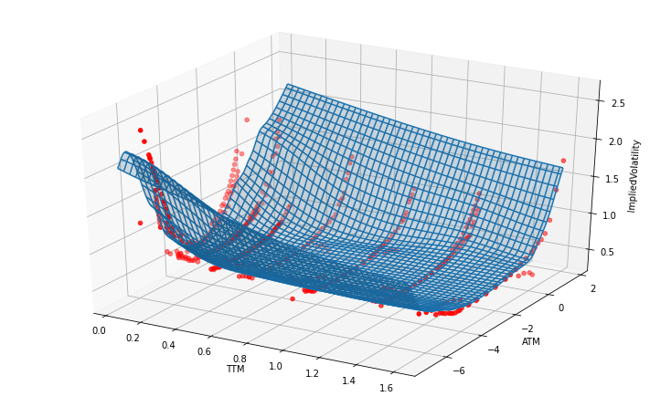

Figure 3. Fitted Volatility Surface on 8 Nov 2022

#### **2.2.2.2. Heston Model**

The Heston model extends the well-known Black-Scholes options, it is defined by a system of SDEs, to describe the movement of asset prices, where an asset’s price and volatility follow random, Brownian motion processes.

|  |  |
| --- | --- |
|  | -volatility of volatility  Θ - long-term price variance  Κ- rate of mean reversion to the long term price variance  -Brownian motion of asset price  - Brownian motion of asset’s price variance  ρQ - correlation between and |

Heston model provides a closed form solution for European Options. Hence, we will use this discovery to calibrate the parameters for the model. The call option price is given by the below equation where and are to be

evaluated using integration ([More Info](https://xilinx.github.io/Vitis_Libraries/quantitative_finance/2021.2/methods/cf-ht.html)). The results for the model are available under **Results of Volatility Models.**

# **3. Pricing and Estimating Sensitivities of the Product**

## **3.1. Pricing the Product**

We will be pricing the product under risk neutral measure. For all simulation methods, we will generate 10000 price paths. The same random variables will be used to simulate the price paths across all simulation methods for a fair comparison.

### **3.1.1. Without callable feature**

#### **3.1.1.1. Standard Monte-Carlo**

Under standard Monte-Carlo (MC), we determine the price of the product by evaluating the payoffs of each path, and take the mean of the payoffs discounted to the current time step.

Standard error of estimation using Monte Carlo is. Hence, by reducing variance we are able to reduce the standard error of estimation.

#### **3.1.1.2. Antithetic Variates**

Antithetic variance reduction is a popular variance reduction technique that has two important advantages, it reduces the number of normal samples to be taken to generate N paths and reduces variance of the paths. So we generate standard normals Y1= {*Z1,.....,Zn/2*} *and Y2=* {*-Z1,.....,-Zn/2*} and from the below equation if <0, we are able to reduce variance.

#### **3.1.1.3. Control Variates**

This method of variance reduction takes advantage of random variables with known expected value and positively correlated with the variable under consideration. But a rather high degree of correlation is needed for a control variate to yield substantial benefits. *Note we are only implementing CV in a risk neutral world.*

#### **3.1.1.4. Empirical Martingale Correction**

To improve simulation quality, we can employ a simple correction method called empirical martingale simulation (EMS). The risk neutral evaluation provides us with Martingale Property. But due discretization and standard error it does hold while simulating.

Martingale Property

Hence we will make some changes to the assets prices to make the price paths abide by Martingale Property.

Now, we compared the variance reduction techniques by simulating 10000 and ensured the same randomness used for each technique.

| **Variance Reduction Technique** | **Variance** |
| --- | --- |
| Without Variance Reduction | 1.925 |
| Antithetic Variates | 1.922 |
| **Control Variate using Final Level as Control** | **1.697** |
| Control Variate using Min Level as Control | 1.804 |
| **Empirical Martingale Correction** | **1.914** |

### **3.1.2. With callable feature**

With callable feature, we can evaluate the price of the product by using a method similar to that of pricing a Bermudan option, but instead the decision to call lies with the issuer. As such, we assume that the issuer is maximizing and would make the optimal decision at each time step. The product is priced backwards, by first calculating the payoff of the product at the time to maturity from simulated price paths. Then, we calculate the expected payoff of the product backwards from the last early redemption date, by comparing the redemption cost to the regressed price of the product determined by regressing the simulated prices at that time step to the discounted payoffs. As we are maximizing from the issuer’s perspective, we will only choose to call the product if the cost of redemption is lower than the conditional expected discounted cash flow. If it is determined that the issuer should call the product, then the payoff at that time step is the redemption cost. After simulating all the early redemption dates, the payoffs can be discounted back and averaged in order to obtain the product pricing at time t.

While more advanced methods can be used to perform regression, such as machine learning or neural networks, in our case we performed simple polynomial regression up to degree 2 using [Sklearn](https://scikit-learn.org/stable/modules/generated/sklearn.linear_model.LinearRegression.html).

For pricing the product with callable features, variance reduction techniques such as antithetic variates and control variates may not be applicable. As such, only EMC will be performed on top of standard MC simulation. Variance reduced pricings will be simulated instead by subtracting the premium difference obtained from standard MC between the callable and non-callable product pricings.

## **3.2. Estimating sensitivities**

We estimated the sensitivities - Delta, 𝛅 and Gamma, 𝚪 using the Finite Difference Method (FDM). Delta refers to the rate of change of an option price with respect to the change in the underlying asset price, whereas Gamma refers to the rate of change of delta with respect to the underlying asset price.

We generated a standard normal random variable for , then compute the price path for , evaluate the payoffs and lastly, estimate the respectively sensitivities using the following equation: and , where . We then repeat these steps with a rolling window of 1 year for 62 days.

# **4. Data and Backtesting Results**

## **4.1 Data Used**

We are using the following data, US treasury Bonds yield rates available [here](https://home.treasury.gov/policy-issues/financing-the-government/interest-rate-statistics), YFinance API incorporated in python to retrieve real-time prices of our underlying asset, and Bloomberg terminal to collect Call option data for 8 November 2022. Retrieved the actual prices of the product during the back-testing period from the [Product Page](https://derivative.credit-suisse.com/ch/ch/en/detail/callable-brc-credit-suisse-10-00-p-a/CH1149494689/114949468).

## **4.2 Backtesting Methodology and Results**

We are performing backtesting from 15 August 2022 to 8 November 2022. By the help of the above collected data we perform simulations and estimate the derivative price using all data available on the day. After testing multiple rolling windows of 1 year, 6 months and 3 months. We found out that window size of 3 months is yielding the best results.

|  |  |  |  |  |  |  |  |  |  |
| --- | --- | --- | --- | --- | --- | --- | --- | --- | --- |
| |  |  | | --- | --- | | **Rolling Window** | **RMSE** | | **3 Months** | **70.89** | | 6 Months | 82.96 | | 1 Year | 105.21 |  **4.2.1. Results with 3 months rolling window** | |
| Figure 4: Estimated Price of Product with and without callable features | |  |  | | --- | --- | | **Method** | **RMSE** | | GBM Non-Callable(NC) | 75.269 | | AV NC | 75.349 | | CV Final Level NC | 75.257 | | CV Min Level NC | 110.455 | | EMS NC | 75.139 | | GBM Callable | 71.28 | | **EMS Callable** | **71.11** | |

We notice that the gap between callable and non-callable decreases as we move forward which is we speculate is due to the decreasing trend of the product price, which makes the redemption cost higher than the F value from regression. Hence the probability of redeeming the product is lesser, this property was very well explained by Figure 3. Another interesting thing to notice is the gap again starts to increase when the estimated product experiences a rising trend around 35 Market day until 50 Market day.

Our estimation is able to capture the general trend of the product price and more importantly it was able to capture the two major dips (red dots) and rises (green dots) which happened during the backtesting period.

Using GBM the difference between Callable and Non-callable Estimated Price : **6.912 CHF**

Using EMS the difference between Callable and Non-callable Estimated Price : **6.896 CHF**

## **4.3. Estimated Sensitivities**

|  |  |
| --- | --- |
|  |  |
| Figure 5: Estimates of 𝛅 with and without callable features | Figure 6: Estimates of 𝚪 with and without callable features |

Based on Figure 5, we can observe that the 𝛅 estimate for non-callable is slightly higher than that of the callable, this is due to the fact that non-callable is more closely related to the underlying asset price. This figure fully captures the major dips in derivative price that happened during the backtesting period as a unit price change in underlying asset, will now lead to a higher change in option prices. On the other hand, in Figure 6, we can observe how a unit price change in underlying asset price can change the amount of delta for each market day.

## **4.4. Results of CIR model**

|  |  |
| --- | --- |
|  |  |
| Figure 7: CIR without callable features | Figure 8: CIR with callable features |

Although we expect that the CIR model would perform better than GBM, from the graphs above, we can observe that the CIR model performed worse than the GBM. This could be because the CIR model is a one-factor structure model where only a single variable is generating stochastic movements in the interest rates. However, in reality, there could be more than one source of uncertainty. In addition, the performance of the CIR model with callable is comparable with the GBM.

## **4.5. Results of Volatility Models**

Call option data was collected from Bloomberg terminal on 8 November 2022 only. As such, backtesting cannot be performed. Hence, we will only price the product on 8 November.

### **4.5.1. Implied Volatility**

Price estimate on 2022-11-08 with implied volatility : **755.85**

Actual Price from Product Page : **826.6**

From these results, it is likely that the implied volatility is a lot higher than the actual volatility, perhaps due to investors’ perception of the stock being much more risky than reality due to many news about Credit Suisse (going bankrupt, scandals), which results in a lower pricing with implied volatility than actual.

### **4.5.2. Heston Model**

First,we will collect European call options data for our underlying asset using Bloomberg. We will use this data to create a volatility surface. We will get the interest rates from US Treasury Bond yield Rates and form an interpolated curve in order to calculate rates for any particular date corresponding to the maturity date of our option. Then we will retrieve the last traded price of the option(So) and perform calibration by reducing the least square error. We will use the python [Scipy package to perform SLSQP](https://docs.scipy.org/doc/scipy/reference/optimize.minimize-slsqp.html) for minimization of error. Note this process could take time hence we decided to set the maximum iteration to 1e4.

|  |  |  |  |  |
| --- | --- | --- | --- | --- |
| **Parameters** | **Initial Value** | **Lower Bound** | **Upper Bound** | **Results** |
| σ | 0.5 | 0.001 | 1 | **0.39975** |
| Θ | 0.5 | 0.001 | 0.5 | **0.30284** |
| Κ | 5 | 1 | 100 | **2.97761** |
| ρ | -0.5 | -1 | 1 | **-0.72355** |
| v0 | 0.5 | 0.001 | 0.5 | **0.318257** |

Figure 9: Represents summary of Bounds, Initial Value and Final Values of parameters after calibration

After we have calibrated the parameters we will use these to simulate our assets’ prices. We will discretize the Heston SDEs using Euler Approximation. Our pseudocode is available in the appendix.

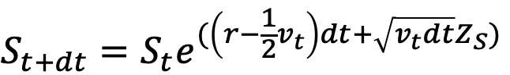

Price estimate on 2022-11-08 using Heston model without callable: **847.660**

Price estimate on 2022-11-08 using Heston model with callable: **838.176**

Actual Price from Product Page : **826.6**

# **5. Improving the Time Efficiency of Our Simulations**

We leveraged the use of parallel thread to speed up the process of Simulation on Python and Efficient just-in-time compilers to tailor the bytecode to our system capabilities. We are using the Numba package with JIT decorator which uses the LLVM compiler library to generate a machine code version of your function, tailored to your CPU capabilities. And Python Threading library to create threads and assign them to parallel workers.It decreased the runtime execution by 60-70%. After Numba and parallel processing it takes 20 seconds to generate 1 million simulations for the GBM process.

# **6. Conclusion and Reflection**

To conclude, while the simulated pricings in the backtest do follow the trends in the actual data and are able to capture major dips and rises, there is still a noticeable difference between the simulations and the actual data, that we did not manage to model accurately. The difference in premium between the callable and non-callable product is also quite low, this is because the product only has two early redemption dates and we noticed the probability of calling back the product is also low around 0.25. We also performed some error analysis in order to find reasons behind the largest errors. Such as on 27th October we observed a large error which when we backtracked,could be due Credit Suisse unveiling their new strategy which aims to focus from investment banking towards rich clients and re-allocate capital to global wealth management business, another case of large error was on 23rd September which may account to Credit Suisse looking for capital to revamp their its investment banking business and thinking to quit the US markets announced by Reuters on 22nd September. We also observe an overall trend of increasing errors which we believe is due to our underlying asset being in the limelight for most of the 2022 announcing various changes in leaderships,strategies,etc and also drastic changes in inflation and interest rates is affecting the Banking and asset management sector such as our asset has caused a lot of deviation. Hence, we suggest for future work we should try a model with stochastic volatility and stochastic interest rates together.

# **7. References**

1. Heston, S. L. (1993). A closed-form solution for options with stochastic volatility with applications to bond and currency options. *The review of financial studies*, *6*(2), 327-343.
2. Heston Model Calibration Tutorial : <https://quantpy.com.au/stochastic-volatility-models/heston-model-calibration-to-option-prices/>
3. <https://derivative.credit-suisse.com/ch/ch/en/detail/callable-brc-credit-suisse-10-00-p-a/CH1149494689/114949468>
4. <https://home.treasury.gov/policy-issues/financing-the-government/interest-rate-statistics?data=yield%27>
5. Orlando, G., Bufalo, M., & Mininni, R. M. (2019, September). Interest rates calibration with a CIR model. ResearchGate. https://www.researchgate.net/profile/Rosa-Mininni/publication/335980054_Interest_rates_calibration_with_a_CIR_model/links/5d95ca9a92851c2f70e63dce/Interest-rates-calibration-with-a-CIR-model.pdf

**Appendix**

**Backtesting Results**

|  |  |
| --- | --- |
|  |  |
| Separate graphs for 3 month rolling window | |
|  |  |
| Backtesting graph using a 6 month rolling window | Backtesting graph using a 1-year rolling window |

**Error Analysis**

|  |  |
| --- | --- |
|  | Dates with Largest Errors according to the graph:  **2022-08-27**  **2022-08-25**  **2022-09-23**  **2022-09-28**  **2022-10-27** |

**CIR Model**

Steps for Calibrating CIR Model Parameters using Microsoft Excel:

1. Retrieve historical US Daily Treasury Par Yield Curve Rates
2. Set γ as the average interest rate
3. Calculate the sum of residual terms,
4. Minimising RSS with respect to discrete drift, Φ
5. Calculate κ = log(1/Φ)
6. Calculate the discrete volatility, σa from RSS
7. Calculate σ from discrete volatility
8. Repeat steps 2-7 for a rolling window of 1 year for 62 days

**Implied Volatility**

Call option data was also collected on 15 Aug 2022. However, the volatility surface obtained was not usual, perhaps due to the presence of outliers present in the data collected.

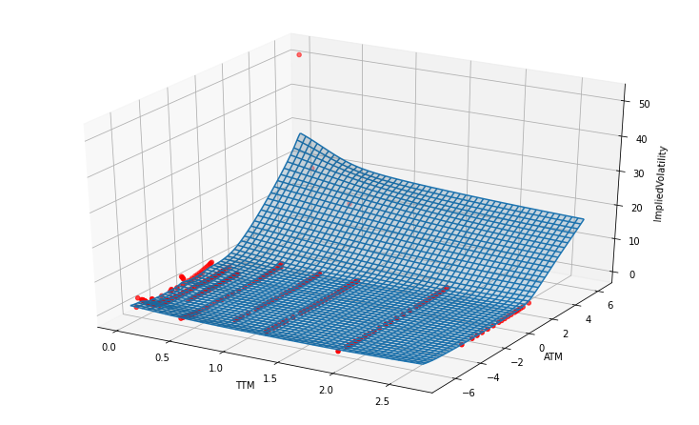

As a result, the pricing of the product was 742.95 when using implied volatility.

**Heston model**

Our pseudocode to generate the assets prices using Heston model:

1. i = 0
2. Generate Standard Normal Variables Zs and Zv using correlation between dWs and dWv provided.This can be done by generating two Standard Normal variable Z1 and Z2 and set

i. Zv = Z1 ii. Zs = ρ*Z1 + Z2*(1-ρ2)½.

1. Set Si using the Euler Discretization formula and Set Vi using the Euler Discretization formula.
2. Repeat steps 3-6 for M times where M is the number of time units (Ex. 252 days for daily simulation of 1 year).
3. Repeat 1-6 for the amount of Simulations N

|  |
| --- |
| Fig: 10000 Simulation of Asset Prices and Variances using Heston |